* **draw()**

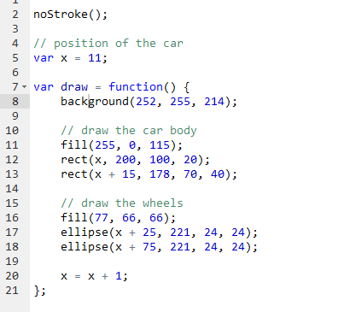

Of course you have to call back, but hey, looks like they don’t feel the need to explain it(so it is called automatically when you call your variable draw I presume). Still, make sure you put the background inside the loop, or you will get a solitary end game-like result (with all the cards springing everywhere and shit).

**MouseX, MouseY**

Both these variables are automatically set by the browser, you don’t have to do anything.

Here you make a cursor that follows your mouse but stays in the same column (visual aid when reading a paragraph?)

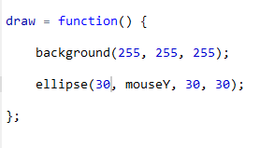

You can program the color to change with the position of the mouse

http://i.gyazo.com/2706119819654e7f98384094aafa3c2a.png

**Incrementing shortcuts**

Ellipse slowly ebbing away:

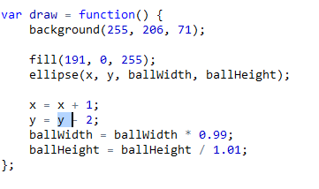

**Bezier Curve**

Used in conjunction with beginShape() and endShape() to draw shapes with bezier curves for sides. The first and last points in a series of curveVertex() lines will be used to guide the beginning and end of a the curve. A minimum of four points is required to draw a tiny curve between the second and third points. The curveVertex() function is an implementation of Catmull-Rom splines.

|  |  |
| --- | --- |
| Parameters: | |
| **x** | the x-coordinate of the vertex |
| **y** | the y-coordinate of the vertex |
|  |  |

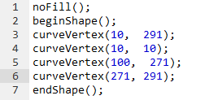

CurveVertex gère lui-même les poignées, sauf la première et la dernière du tracé. C’est important a retenir : la première et la dernière commande curveVertex() d’un tracé sont des poignées et pas des points du dessin. En conséquence, un simple trait sera défini par 4 commandes :   
- la première contient les coordonnées x et y de la poignée de départ  
- la deuxième contient les coordonnées x et y du premier point  
- la troisième contient les coordonnées x et y du deuxième point  
- la quatrième contient les coordonnées x et y de la poignée de fin de tracé.

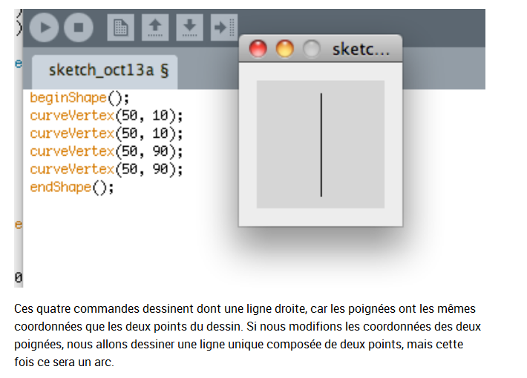

**text()**

display strings with text(string, x, y);

You can display the coordinates of the cursor in real time with this function:

http://i.gyazo.com/5545ba2378a88540e50883e1a012c9b1.png